Big Data

Introduction
Big Data is a very simple concept – it is data that is too large or too complex to process using traditional methods. John Mashey, who was the chief scientist at Silicon Graphics in the 1990s, coined the term, which first appeared in his presentations back in 1996. There is no preset amount of information, which would be considered a big data – it is simply a data that is too big to process. If a 50-gigabyte dataset qualified as big data ten years ago, today it can be processed with relative ease so it is not a big data anymore. What is considered big data today may be ordinary data tomorrow. Also what is considered big data for one organization may not be such for another company.
To get advantage of the big data a company or an organization must be able to relatively fast process enourmous amounts of data. For example, a bank may want to review few years of customer’s transaction history, then recent purchases as well as check customer’s FICO scores while this customer is still using the bank’s ATM. Once customer is done with the ATM ttansaction he or she may be presented with an ad or an offer that is specifically tailored for this customer. To make this work the bank must harness the power of the big data and be capable of processing it in real time.

Characteristics
Originally, the big data had the following characteristics, referred to as “three V’s”:
- Volume – today big data volume is measured in terabytes, petabytes (thousands of terabytes), and even exabytes (millions of terabytes) of data.
- Variety – big data may come from a number of different sources in various formats and may represent the same record or event from different angles.
- Velocity – the speed with which big data is generated. Sometimes big data generation outpaces big data processing so real-time processing becomes problematic.
Consider the volume, variety, and velocity of the big data in the following example: during Large Hadron Collider experiments, scientists receive data from about 150 million sensors at a rate of 40 million times per second. There are nearly 600 million collisions per second so researchers must filter out and record only relevant information. In the end, it represents less than 0.001% of the sensor stream data, yet the experiments produced about 25 petabytes of data in 2012, or more than 70 terabytes of raw data every day. Handling such volumes of data on daily bases is becoming today’s norm not in the scientific research labs alone, but in business as well. For instance, a running Boeing jet engine produces 20 terabytes of data per hour, which engineers can monitor and examine in near real time, or mine later for engineering improvements.
More recently, researchers added three more “V’s” to the big data characteristics:
- Variability – big data is loosely structured and may be inconsistent at times; this hampers the process of handling and managing the data effectively.
- Veracity – the reliability of captured data can vary greatly. Accurate analysis depends on the quality of the source data.
- Value – big data is useful only when it’s processed so value reflects the need of processing of the big data as opposed to simple collection and storage. For instance, according to 2012 estimates if US health sector could leverage the value of the big data it already has it could save up to $300 billion per year.

Challenges
In addition to the rightful praises big data got it also received its share of critique. One of the most serious issues companies are facing is that the output of the big data processing usually is as good as the people who work with it. Since it is often loosely structured, the employees must understand mathematical properties and dataset correlation of the big data. According to Corporate Executive Board research, conducted on over 5,000 employees from 22 companies, only 38% of employees, working with the big data, have the necessary skills to make a good use of it. Another critique closely relates to the previous one – big data provides insight into the past or, at best, current state of affairs. If future is similar to the past then current algorithms can provide a helpful insight, if the future is dynamic then big data may be useless for business planning purposes so the results are as good as the predictive abilities of the data analysts. Additionally, the pure nature of big data makes it difficult to process. Big data analysis is often shallow compared to analysis of smaller datasets. In many big data projects, there is no large data analysis happening, because the Extract, Transform, Load stage of data preprocessing is proven very challenging.

Vendors
Big data usually is too big and too complex to process on a single computer so companies use clusters of hundreds and thousands of servers to work with big data. Some of the leaders that supply solutions for big data processing:
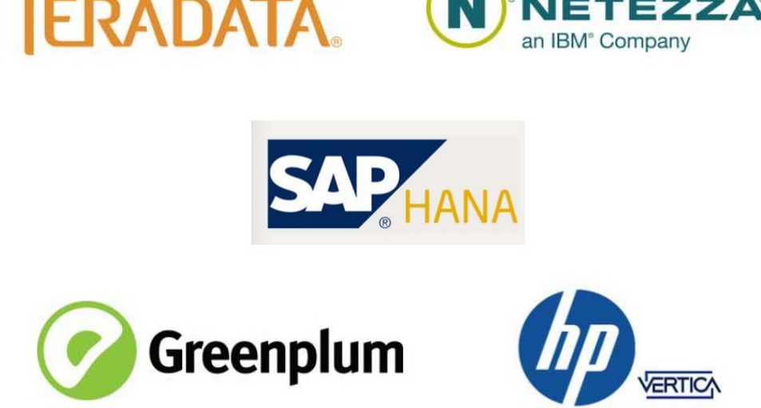
In 2014 SAP paired with Silicon Graphics to present SAP HANA system that is capable of sifting through a quarter of a trillion records in less than half of a second.

Case study
“We want to know what every product in the world is. We want to know who every person in the world is. And we want to have the ability to connect them together in a transaction.” Walmart’s global e-commerce president/CEO Neil Ashe in 2013.
Walmart started using big data well before using the big data became cool, however they used a variety of systems, and all presented their own set of challenges. In 2011, Walmart created a Big Fast Data Team and tasked it with finding new ways to use big data in retail business. They created the Social Genome project, which focuses on generating targeted ads on social networks based on people’s conversations with their friends. For instance, if a person talks to her friends about movies a lot then next time the person says “I love Salt!” the Social Genome recognizes that she is talking about the movie Salt and not the condiment.
In 2012, Walmart consolidated data from ten different websites, hosted on Oracle, Netezza and Greenplum hardware into one, stored on a 250-node Hadoop cluster. The cluster operates with petabytes of existing data and terabytes of new data added every day. It sifts through nearly 200 million weekly transactions, millions of products, and through keyword cues left by the hundreds of millions of potential customers on social networks, trying to predict your next want and be there with an offer you won’t be able to resist.
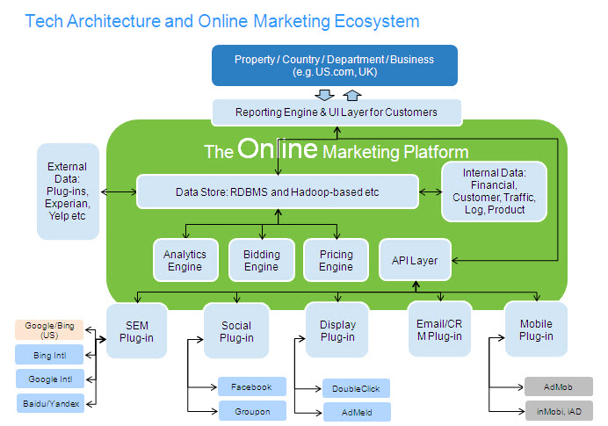

Bibliography
Diebold, Francis X. "A Personal Perspective on the Origin(s) and Development of “Big
Data”." (n.d.): n. pag. University of Pennsylvania. 26 Nov. 2012. Web. 31 July 2015. <http://www.ssc.upenn.edu/~fdiebold/papers/paper112/Diebold_Big_Data.pdf>.
Floyer, David. "Big Data | The Definition of Enterprise Big Data - Wikibon."The Definition
of Enterprise Big Data. N.p., 25 May 2015. Web. 31 July 2015.
<http://wikibon.org/wiki/v/Enterprise_Big-data>.
FSN Publishing Limited. "Mastering Big Data: CFO Strategies to Transform Insight into
Opportunity." FSN Publishing Limited. N.p., 18 Dec. 2012. Web. 31 July 2015.
<http://www.fsn.co.uk/channel_bi_bpm_cpm/mastering_big_data_cfo_strategies_to_transform_insight_into_opportunity#.Vb7wXPlViko>.
Marr, Bernard. "Big Data, Walmart And The Future Of Retail." LinkedIn. N.p., 19 Feb. 2015.
Web. 31 July 2015. <https://www.linkedin.com/pulse/big-data-walmart-future-retail-bernard-marr>.
Marr, Bernard. "Walmart: The Big Data Skills Crisis And Recruiting Analytics
Talent." Forbes. Forbes Magazine, 7 June 2015. Web. 31 July 2015. <http://www.forbes.com/sites/bernardmarr/2015/07/06/walmart-the-big-data-skills-crisis-and-recruiting-analytics-talent/>.
Rijmenam, Mark Van. "Connecting Data and People." Datafloq. N.p., 15 Mar. 2015. Web.
31 July 2015. <https://datafloq.com/read/walmart-making-big-data-part-dna/509>.
Shah, Shvetank, Andrew Horne, and Jaime Capellá. "Good Data Won't Guarantee Good
Decisions." Harvard Business Review. N.p., 01 Apr. 2012. Web. 31 July 2015. <https://hbr.org/2012/04/good-data-wont-guarantee-good-decisions/ar/1>.
Silicon Graphics, Intl. "SGI in the Spotlight at SAP D-code Event in Las Vegas." YouTube.
YouTube, 31 Oct. 2014. Web. 31 July 2015. <https://www.youtube.com/watch?v=zx1EDzU2n1s>.

Glossary
Big Data – data that is too large or complex to process using traditional methods. Big data does not have a preset measure – what is considered "big data" today may be “ordinary data” tomorrow.
Cluster – in a computer system, a cluster is a group of servers and other resources that act like a single system and enable high availability or, in some cases, load balancing and parallel processing.
Hadoop – free, Java-based programming framework that supports the processing of large data sets in a distributed computing environment. It is part of the Apache project sponsored by the Apache Software Foundation.
Hadoop cluster – a Hadoop cluster is a special type of computational cluster designed specifically for storing and analyzing huge amounts of unstructured data in a distributed computing environment.
Real-time processing – data processing that appears to take place, or actually takes place, instantaneously upon data entry or receipt of a command
SAP – SAP SE (Systems, Applications & Products in data processing) is a German multinational software corporation that makes enterprise software to manage business operations and customer relations.
SAP HANA – SAP HANA is an in-memory, column-oriented, relational database management system developed and marketed by SAP SE.

