Team Awesome Possums: Team Members: Ian Hella, Lisa Kim, Brenton Dow

Date: 8/5/2015

**Project 1 Zodiac Sign:**

Create an ASP.Net VB website that tells you your horoscope based on the birthday the user enters. Enter the birthday in the correct format (MM/DD) and click the compute button and the program will display information pertaining to their specific sign.

Output:

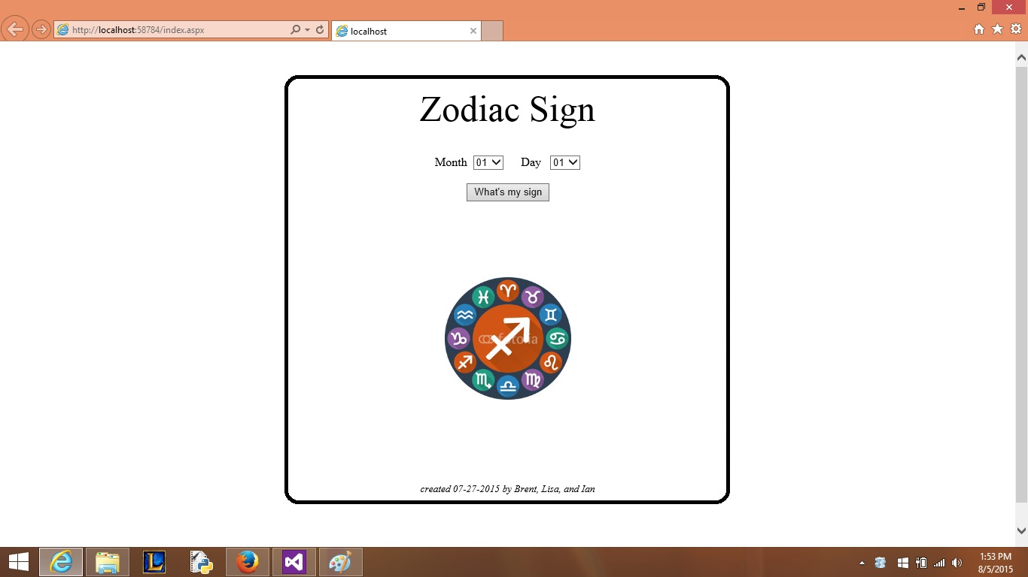

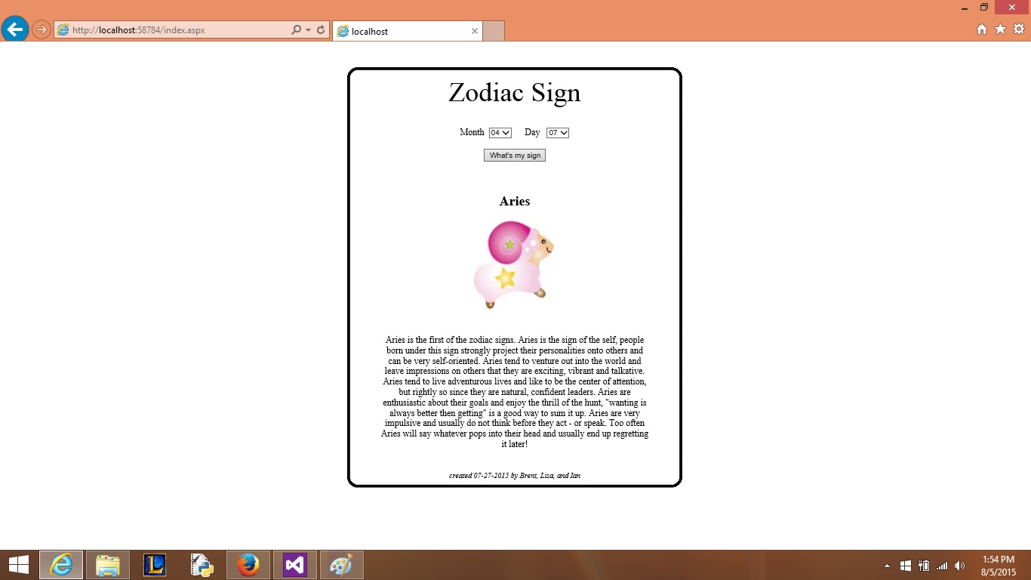

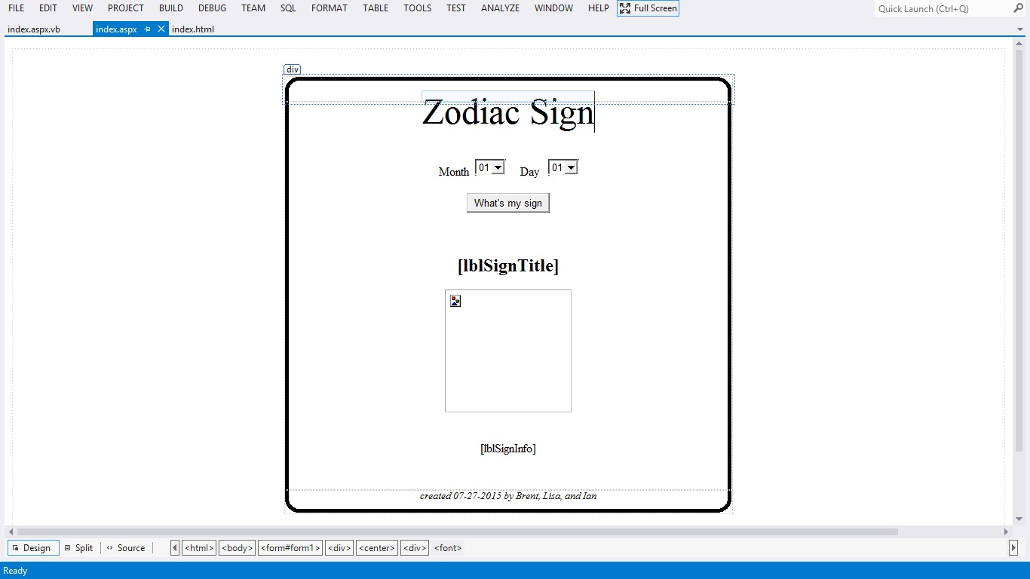

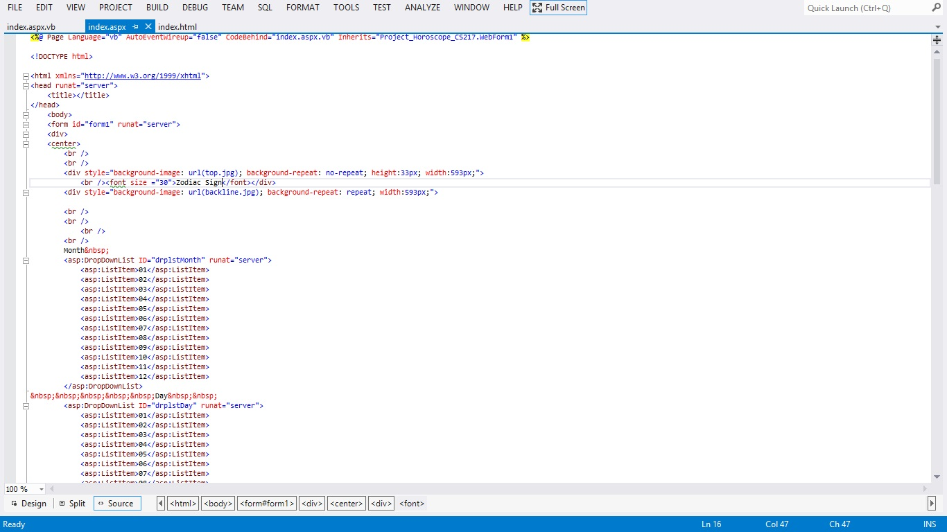

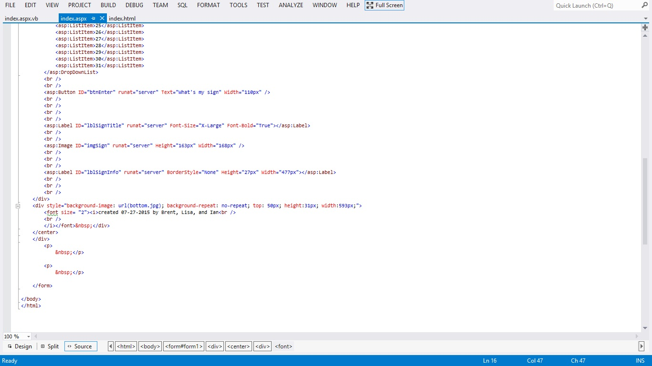

<%@ Page Language="vb" AutoEventWireup="false" CodeBehind="index.aspx.vb" Inherits="Project_Horoscope_CS217.WebForm1" %>

<!DOCTYPE html>

<html xmlns="http://www.w3.org/1999/xhtml">

<head runat="server">

<title></title>

</head>

<body>

<form id="form1" runat="server">

<div>

<center>

<br />

<br />

<div style="background-image: url(top.jpg); background-repeat: no-repeat; height:33px; width:593px;">

<br /><font size ="30">Zodiac Sign</font></div>

<div style="background-image: url(backline.jpg); background-repeat: repeat; width:593px;">

<br />

<br />

<br />

<br />

Month&nbsp;

<asp:DropDownList ID="drplstMonth" runat="server">

<asp:ListItem>01</asp:ListItem>

<asp:ListItem>02</asp:ListItem>

<asp:ListItem>03</asp:ListItem>

<asp:ListItem>04</asp:ListItem>

<asp:ListItem>05</asp:ListItem>

<asp:ListItem>06</asp:ListItem>

<asp:ListItem>07</asp:ListItem>

<asp:ListItem>08</asp:ListItem>

<asp:ListItem>09</asp:ListItem>

<asp:ListItem>10</asp:ListItem>

<asp:ListItem>11</asp:ListItem>

<asp:ListItem>12</asp:ListItem>

</asp:DropDownList>

&nbsp;&nbsp;&nbsp;&nbsp;&nbsp;Day&nbsp;&nbsp;

<asp:DropDownList ID="drplstDay" runat="server">

<asp:ListItem>01</asp:ListItem>

<asp:ListItem>02</asp:ListItem>

<asp:ListItem>03</asp:ListItem>

<asp:ListItem>04</asp:ListItem>

<asp:ListItem>05</asp:ListItem>

<asp:ListItem>06</asp:ListItem>

<asp:ListItem>07</asp:ListItem>

<asp:ListItem>08</asp:ListItem>

<asp:ListItem>09</asp:ListItem>

<asp:ListItem>10</asp:ListItem>

<asp:ListItem>11</asp:ListItem>

<asp:ListItem>12</asp:ListItem>

<asp:ListItem>13</asp:ListItem>

<asp:ListItem>14</asp:ListItem>

<asp:ListItem>15</asp:ListItem>

<asp:ListItem>16</asp:ListItem>

<asp:ListItem>17</asp:ListItem>

<asp:ListItem>18</asp:ListItem>

<asp:ListItem>19</asp:ListItem>

<asp:ListItem>20</asp:ListItem>

<asp:ListItem>21</asp:ListItem>

<asp:ListItem>22</asp:ListItem>

<asp:ListItem>23</asp:ListItem>

<asp:ListItem>24</asp:ListItem>

<asp:ListItem>25</asp:ListItem>

<asp:ListItem>26</asp:ListItem>

<asp:ListItem>27</asp:ListItem>

<asp:ListItem>28</asp:ListItem>

<asp:ListItem>29</asp:ListItem>

<asp:ListItem>30</asp:ListItem>

<asp:ListItem>31</asp:ListItem>

</asp:DropDownList>

<br />

<br />

<asp:Button ID="btnEnter" runat="server" Text="What's my sign" Width="110px" />

<br />

<br />

<br />

<br />

<asp:Label ID="lblSignTitle" runat="server" Font-Size="X-Large" Font-Bold="True"></asp:Label>

<br />

<br />

<asp:Image ID="imgSign" runat="server" Height="163px" Width="168px" />

<br />

<br />

<br />

<asp:Label ID="lblSignInfo" runat="server" BorderStyle="None" Height="27px" Width="477px"></asp:Label>

<br />

<br />

<br />

</div>

<div style="background-image: url(bottom.jpg); background-repeat: no-repeat; top: 50px; height:31px; width:593px;">

<font size= "2"><i>created 07-27-2015 by Brent, Lisa, and Ian<br />

<br />

</i></font>&nbsp;</div>

</center>

</div>

<p>

&nbsp;</p>

<p>

&nbsp;</p>

</form>

</body>

</html>

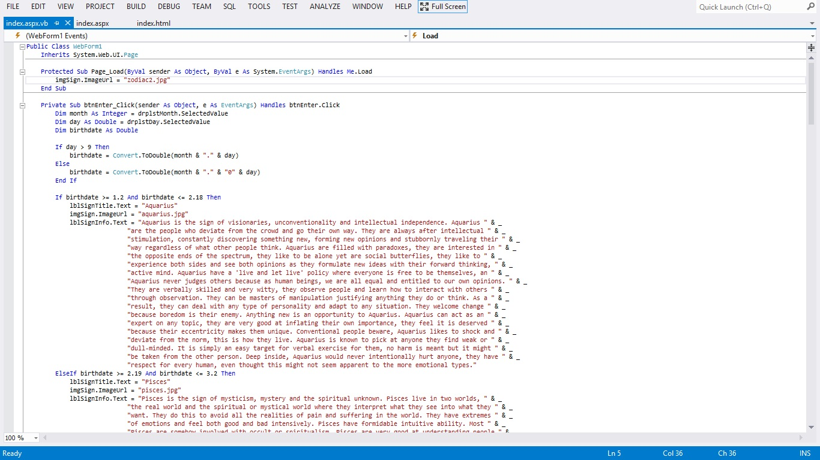

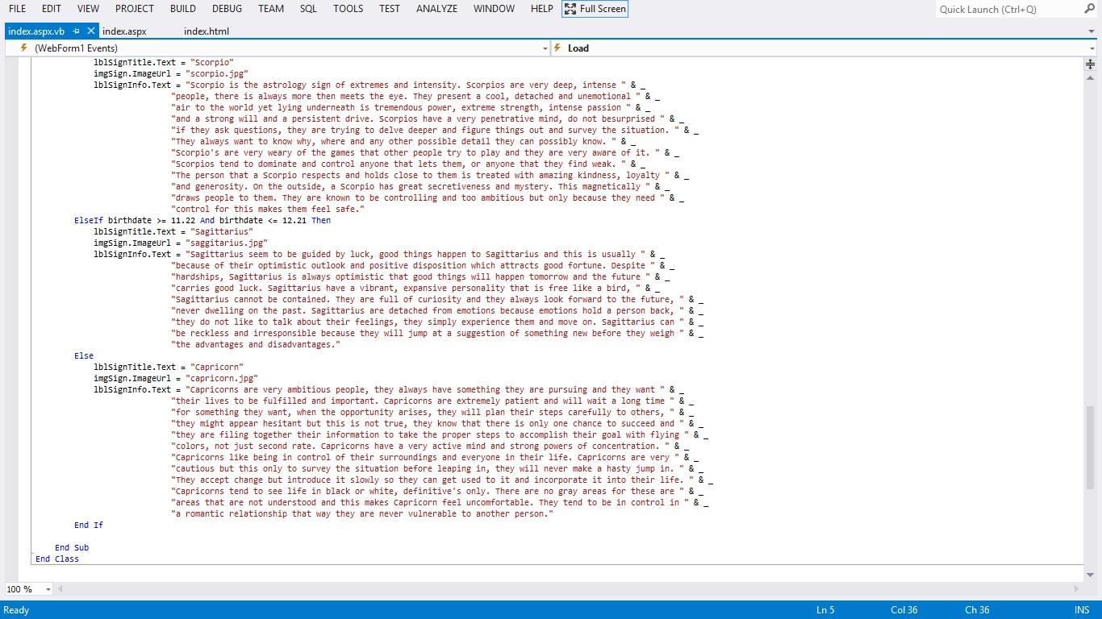

Public Class WebForm1

Inherits System.Web.UI.Page

Protected Sub Page_Load(ByVal sender As Object, ByVal e As System.EventArgs) Handles Me.Load

imgSign.ImageUrl = "zodiac2.jpg"

End Sub

Private Sub btnEnter_Click(sender As Object, e As EventArgs) Handles btnEnter.Click

Dim month As Integer = drplstMonth.SelectedValue

Dim day As Double = drplstDay.SelectedValue

Dim birthdate As Double

If day > 9 Then

birthdate = Convert.ToDouble(month & "." & day)

Else

birthdate = Convert.ToDouble(month & "." & "0" & day)

End If

If birthdate >= 1.2 And birthdate <= 2.18 Then

lblSignTitle.Text = "Aquarius"

imgSign.ImageUrl = "aquarius.jpg"

lblSignInfo.Text = "Aquarius is the sign of visionaries, unconventionality and intellectual independence. Aquarius " & _

"are the people who deviate from the crowd and go their own way. They are always after intellectual " & _

"stimulation, constantly discovering something new, forming new opinions and stubbornly traveling their " & _

"way regardless of what other people think. Aquarius are filled with paradoxes, they are interested in " & _

"the opposite ends of the spectrum, they like to be alone yet are social butterflies, they like to " & _

"experience both sides and see both opinions as they formulate new ideas with their forward thinking, " & _

"active mind. Aquarius have a 'live and let live' policy where everyone is free to be themselves, an " & _

"Aquarius never judges others because as human beings, we are all equal and entitled to our own opinions. " & _

"They are verbally skilled and very witty, they observe people and learn how to interact with others " & _

"through observation. They can be masters of manipulation justifying anything they do or think. As a " & _

"result, they can deal with any type of personality and adapt to any situation. They welcome change " & _

"because boredom is their enemy. Anything new is an opportunity to Aquarius. Aquarius can act as an " & _

"expert on any topic, they are very good at inflating their own importance, they feel it is deserved " & _

"because their eccentricity makes them unique. Conventional people beware, Aquarius likes to shock and " & _

"deviate from the norm, this is how they live. Aquarius is known to pick at anyone they find weak or " & _

"dull-minded. It is simply an easy target for verbal exercise for them, no harm is meant but it might " & _

"be taken from the other person. Deep inside, Aquarius would never intentionally hurt anyone, they have " & _

"respect for every human, even thought this might not seem apparent to the more emotional types."

ElseIf birthdate >= 2.19 And birthdate <= 3.2 Then

lblSignTitle.Text = "Pisces"

imgSign.ImageUrl = "pisces.jpg"

lblSignInfo.Text = "Pisces is the sign of mysticism, mystery and the spiritual unknown. Pisces live in two worlds, " & _

"the real world and the spiritual or mystical world where they interpret what they see into what they " & _

"want. They do this to avoid all the realities of pain and suffering in the world. They have extremes " & _

"of emotions and feel both good and bad intensively. Pisces have formidable intuitive ability. Most " & _

"Pisces are somehow involved with occult or spiritualism. Pisces are very good at understanding people " & _

"for they have the ability to delve into the psyche and see behind a person's motivations. Pisces are " & _

"prone to drug addiction and indulging lifestyles because of their eternal search for themselves and " & _

"their fear of confrontation and having to change a situation, also they justify drug use by allowing " & _

"it to get closer with their 'spiritual selves'. Once they aware this is why they are doing it, it will " & _

"be easier to kick the habit. Pisces are not the pushovers that they may seem, in fact they have strength " & _

"of character and will stand up for what they believe in and and they can do hard work for something they " & _

"believe in. They can be very lazy but only in matters that they do not care about. Pisces is the most " & _

"sensitive of all zodiac signs."

ElseIf birthdate >= 3.21 And birthdate <= 4.2 Then

lblSignTitle.Text = "Aries"

imgSign.ImageUrl = "aries.jpg"

lblSignInfo.Text = "Aries is the first of the zodiac signs. Aries is the sign of the self, people born under this " & _

"sign strongly project their personalities onto others and can be very self-oriented. Aries tend to " & _

"venture out into the world and leave impressions on others that they are exciting, vibrant and " & _

"talkative. Aries tend to live adventurous lives and like to be the center of attention, but rightly " & _

"so since they are natural, confident leaders. Aries are enthusiastic about their goals and enjoy the " & _

"thrill of the hunt, ""wanting is always better then getting"" is a good way to sum it up. Aries are very " & _

"impulsive and usually do not think before they act - or speak. Too often Aries will say whatever pops " & _

"into their head and usually end up regretting it later! "

ElseIf birthdate >= 4.21 And birthdate <= 5.2 Then

lblSignTitle.Text = "Taurus"

imgSign.ImageUrl = "taurus.jpg"

lblSignInfo.Text = "Taurus is the one who has immense perseverance, even when others have given up, the Taurus rages " & _

"on. Solid and persistent, just like the bull, which is Taurus' well suited symbol. Taurus's have a " & _

"well known reputation for being stubborn, which is not necessarily a bad thing. The stubborn streak " & _

"can cause Taurus to butt heads and conflict with other strong character types. Taurus are not fond of " & _

"change. They like the familiar and routine comfort of life. Taurus is easy going and not one to pick " & _

"a fight but should some poor souls attempt to provoke Taurus, the wrath will be known, for they have " & _

"a temper underneath the calm surface. Taurus are very responsive to their surroundings. They like " & _

"decorations, color, anything that appeals to all the senses. Taurus like possessions and the Taurus " & _

"home is nicely decorated with lots of things. Taurus are down to earth, they do not like gaudy, flashy " & _

"or over the top things. They prefer comfortable and creative settings and objects. Taurus likes security, " & _

"in every aspect of their lives from home, to love, to career. Taurus can be secretive, opinionated and " & _

"stingy. Taurus tend to be self-indulgent and lazy, Taurus are master procrastinators of the astrology " & _

"zodiac! They do however have a strong, persistent drive that comes to life when they chose, and no one " & _

"would ever know that they are lazy. The secret to this is that their laziness is pushed aside when it " & _

"comes to themselves. "

ElseIf birthdate >= 5.21 And birthdate <= 6.21 Then

lblSignTitle.Text = "Gemini"

imgSign.ImageUrl = "gemini.jpg"

lblSignInfo.Text = "Gemini people are many sided, quick both in the mind and physically. They are brimming with " & _

"energy and vitality, they are clever with words. They are intelligent and very adaptable to every " & _

"situation and every person. Gemini are curious and always want to know what's going on in the world " & _

"around them. They are not one to sit back and watch the world go by, they want to be involved. This " & _

"can sometimes make Gemini nosy, they do not mind their own business! This is because they really enjoy " & _

"communicating, more so then most other astrology signs, they are the ultimate social butterfly. Gemini " & _

"can talk and talk, but they have interesting things to say, their talk is not mindless babble. They " & _

"have interesting opinions and thoughts on things and are not afraid to speak their mind. They are always " & _

"in the know and are the one to see for the latest juicy gossip. Lacking perseverance, Gemini easily goes " & _

"off topic to explore another thought or idea. Gemini are superficial, they will form opinions on matter " & _

"without diving into them and exploring them fully. This can lead them into thinking they know everything, " & _

"which they usually do but their mind is too busy to be concerned with fine details. Routine and boredom " & _

"are Gemini's biggest fears. Gemini would rather be naive then know the depressing truth, they do not want " & _

"anything putting a damper on their freedom or positive energy. "

ElseIf birthdate >= 6.22 And birthdate <= 7.22 Then

lblSignTitle.Text = "Cancer"

imgSign.ImageUrl = "cancer.jpg"

lblSignInfo.Text = "Cancer is a mysterious sign, filled with contradictions. They want security and comfort yet seek " & _

"new adventure. They are very helpful to others yet sometimes can be cranky and indifferent. Cancer " & _

"has a driving, forceful personality that can be easily hidden beneath a calm, and cool exterior. " & _

"The crab is Cancer's ruling animal and it suits them well, they can come out of their shell and fight " & _

"but they can also hide in their shell of skitter away back into the depths of the ocean. They are very " & _

"unpredictable. With cancer, there is always something more that meets the eye, for they are always " & _

"partially hidden behind the shell. They are a have a deep psyche and intuitive mind that is hidden from " & _

"the world. Cancer is deeply sensitive and easily hurt, this might be why they have their defense shell " & _

"in place, to avoids being hurt by others. They are nurturers so they surround themselves with people, " & _

"whom after a while can offend or hurt a cancer without even knowing they did so, therefore Cancer's " & _

"protective shell keeps them safe from hurt. They are complex, fragile, unpredictable and temperamental " & _

"and need constant support and encouragement, more then any other astrology signs, Cancer needs to be " & _

"needed. When cancer gets the support it needs, it has a tremendous amount to offer in return. When " & _

"cancer gets offended, they tend to sulk instead of confronting the persons face to face. This " & _

"needlessly prolongs the pain and suffering. Cancer is very possessive, not just with material " & _

"possessions but with people as well. Cancer will always want to stay in touch with old friends and " & _

"anyone who has ever been close to them, because it is easier to maintain a friendship then attempt to " & _

"learn to trust a new person. It is easier this way for them emotionally. If you befriend a Cancer, you " & _

"will stay friends for a long time. Cancer makes the perfect mother, this is the sign that represents " & _

"motherhood. They have unconditional love and caring more so then any other astrology sign. Cancer are " & _

"very intuitive. Most of the psychics of the world are Cancer astrology signs. They have an excellent " & _

"memory and are very observant and can read people very well. They can usually tell of other people's " & _

"intentions are good or not. Never dupe a Cancer, they can see your motives. Cancer has a lot of emotional " & _

"issues to deal with but once they overcome this large hump of shyness and insecurity, there is practically " & _

"nothing they can't do. With their strong intuition, sensitivity, powers of observation and intelligence, " & _

"they will have great success in anything they undertake. "

ElseIf birthdate >= 7.23 And birthdate <= 8.22 Then

lblSignTitle.Text = "Leo"

imgSign.ImageUrl = "leo.jpg"

lblSignInfo.Text = "Leo is the lion, this well suited symbol represents Leo very well. They possess a kingdom which " & _

"they protest and cherish. The are high esteemed, honorable and very devoted to themselves in " & _

"particular! The kingdom could be anything from work to home to a partner, whatever it is, you rule it. " & _

"Leo is always center stage and full of flair, they enjoy basking in the spotlight. A Leo always makes " & _

"their presence known. Leo are full of energy that acts like a magnet for other people. Others are " & _

"attracted to Leo's wit, charm, and what they have to say for they speak of things grand and very " & _

"interesting. Leo will never settle for second best. They want only the best which can cause lavish " & _

"excessive spending habits as they enjoy their life of luxury, which is all to easily justified by the " & _

"grand and magnificent Leo! Public image is very important to Leo, with luxurious possessions and ways " & _

"of life, this keeps the public image in high standing. They will do whatever it takes to protect their " & _

"own reputation. Leos are very generous, kind and openhearted people. If a Leo is crossed, they will strike " & _

"back with force but they are not one to hold a grudge, they easily forgive, forget and move on. Leos are " & _

"always trying to make things right in the world, they have larger then life emotions and they need to feel " & _

"like they have accomplished something at the end of the day. They react to situations with action instead " & _

"of sitting back and thinking about it, they are not impulsive however because they look at the future and " & _

"consider consequences of their actions."

ElseIf birthdate >= 8.23 And birthdate <= 9.22 Then

lblSignTitle.Text = "Virgo"

imgSign.ImageUrl = "virgo.jpg"

lblSignInfo.Text = "Virgo exists in the mind, everything is inside. " & _

"To the world, Virgo presents a calm and collected exterior but on the inside, " & _

"nervous uncontrolled intensity in the mind, trying to figure things out, " & _

"how to improve everything, analyzing and thinking. " & _

"Virgo can tire itself out without even moving! Virgo has a constant drive to " & _

"improve and perfect, this can lead to extreme pickiness and finickiest. " & _

"They are pure, their motives are honest never malicious and they want to accomplish something."

ElseIf birthdate >= 9.23 And birthdate <= 10.22 Then

lblSignTitle.Text = "Libra"

imgSign.ImageUrl = "libra.jpg"

lblSignInfo.Text = "Libras are the diplomat of the zodiac. They are able to put themselves in other's shoes " & _

"and see things through another person's point of view. They are the ones that always " & _

"want to make things right and have balance and harmony in their life, their surroundings " & _

"and the lives of the people close to them. They have captivating charm, elegant taste and " & _

"they are easy to like due to their eager-to-please, easygoing nature. " & vbCrLf & vbCrLf & _

"In return for a Libra's amazing ability to be a good listener, sooth and calm people, " & _

"they expect admiration. Libras will gather a group of people, everyone will become " & _

"friends then the Libra will be in the center of the group. They like the attention and " & _

"the admiration for the people that they have brought together. Libras are very intelligent, " & _

"they often hide this inside their easygoing exterior. They express their intelligence " & _

"through creativity, most are involved in some sort of artistic or creative pursuit. " & _

"Many people overlook just how intelligent a Libra actually is. When others see a Libras " & _

"wide range of interests and hobbies, their intelligence and creativity is more then obvious. " & _

"Libras love variety and different situations. They welcome change. Libras love luxury. " & _

"They will spend lots of money and surround themselves with beautiful things and they seem " & _

"to be constantly fussing over their appearance. They love anything upscale and classy. " & _

"Libras work hard to please others, this they do an others find them incredibly captivating. "

ElseIf birthdate >= 10.23 And birthdate <= 11.21 Then

lblSignTitle.Text = "Scorpio"

imgSign.ImageUrl = "scorpio.jpg"

lblSignInfo.Text = "Scorpio is the astrology sign of extremes and intensity. Scorpios are very deep, intense " & _

"people, there is always more then meets the eye. They present a cool, detached and unemotional " & _

"air to the world yet lying underneath is tremendous power, extreme strength, intense passion " & _

"and a strong will and a persistent drive. Scorpios have a very penetrative mind, do not besurprised " & _

"if they ask questions, they are trying to delve deeper and figure things out and survey the situation. " & _

"They always want to know why, where and any other possible detail they can possibly know. " & _

"Scorpio's are very weary of the games that other people try to play and they are very aware of it. " & _

"Scorpios tend to dominate and control anyone that lets them, or anyone that they find weak. " & _

"The person that a Scorpio respects and holds close to them is treated with amazing kindness, loyalty " & _

"and generosity. On the outside, a Scorpio has great secretiveness and mystery. This magnetically " & _

"draws people to them. They are known to be controlling and too ambitious but only because they need " & _

"control for this makes them feel safe."

ElseIf birthdate >= 11.22 And birthdate <= 12.21 Then

lblSignTitle.Text = "Sagittarius"

imgSign.ImageUrl = "saggitarius.jpg"

lblSignInfo.Text = "Sagittarius seem to be guided by luck, good things happen to Sagittarius and this is usually " & _

"because of their optimistic outlook and positive disposition which attracts good fortune. Despite " & _

"hardships, Sagittarius is always optimistic that good things will happen tomorrow and the future " & _

"carries good luck. Sagittarius have a vibrant, expansive personality that is free like a bird, " & _

"Sagittarius cannot be contained. They are full of curiosity and they always look forward to the future, " & _

"never dwelling on the past. Sagittarius are detached from emotions because emotions hold a person back, " & _

"they do not like to talk about their feelings, they simply experience them and move on. Sagittarius can " & _

"be reckless and irresponsible because they will jump at a suggestion of something new before they weigh " & _

"the advantages and disadvantages."

Else

lblSignTitle.Text = "Capricorn"

imgSign.ImageUrl = "capricorn.jpg"

lblSignInfo.Text = "Capricorns are very ambitious people, they always have something they are pursuing and they want " & _

"their lives to be fulfilled and important. Capricorns are extremely patient and will wait a long time " & _

"for something they want, when the opportunity arises, they will plan their steps carefully to others, " & _

"they might appear hesitant but this is not true, they know that there is only one chance to succeed and " & _

"they are filing together their information to take the proper steps to accomplish their goal with flying " & _

"colors, not just second rate. Capricorns have a very active mind and strong powers of concentration. " & _

"Capricorns like being in control of their surroundings and everyone in their life. Capricorns are very " & _

"cautious but this only to survey the situation before leaping in, they will never make a hasty jump in. " & _

"They accept change but introduce it slowly so they can get used to it and incorporate it into their life. " & _

"Capricorns tend to see life in black or white, definitive's only. There are no gray areas for these are " & _

"areas that are not understood and this makes Capricorn feel uncomfortable. They tend to be in control in " & _

"a romantic relationship that way they are never vulnerable to another person."

End If

End Sub

End Class